Do you need support? Your Team Around the Family …….

Why?
After the needs of your
family have been identified. It is important for support to be put in place. To ensure that you and your family receive the right support, to help with the concern, build your resilience and find your voice.
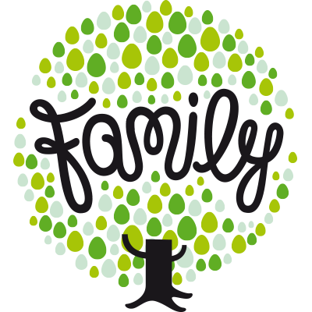
Who?
Once you have agreed for a TAF to be held, the lead practitioner will speak with you about who you would like to invite. This could be anyone from friends and family to professionals such as a Youth Worker, Health Visitor or a teacher.
What?
Team Around the Family (TAF) meeting is a way of receiving extra support for your family needs, to put the support in place and helping you and your family move forward

The TAF…….
The lead professional will complete the paperwork during the TAF to ensure all views are capture. As this is your TAF, it is important that you understand everything that has been discussed and are happy with the actions.

You will then be asked for permission to share your family plan with other professionals, such as those that couldn’t attend

At the end of the TAF, a review meeting should be agreed.
Where & when?
This is your family meeting; therefore you can have your say around where & when the meeting is held.
At home, a school or somewhere neutral, also which time of day best suit your family (around your working hours)
Speak with the lead practitioner to confirm the venue.

At review, you will all have time to reflect on the orginal family plan, to see what the outcome of actions is. This is your time to share your concerns or success story

If it is agreed by all within the plan, your family no longer require support. Your family TAF can be closed.
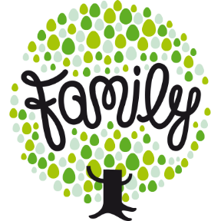

The following website could be useful to you – please take some time to visit and contact the appropriate service
That would meet your family’s needs
Attendance

www.essexlocaloffer.org.uk

PACE – parents against Child exploiation
Children’s
behaviour

FRANK – friendly and confidential advice (drugs & alcohol)

www.snapcharity.org Special Needs and Parents

www.nationaldomesticviolencehelpline.org.uk

kooth.com – online safe and secure website for young people to chat freely
Bereavement
www.mind.org.uk – support for Mental health
Parenting
support
http://essexfamilywellbeing.co.uk - Essex Child & Family Well-Being Service

www.ican.org.uk – communication for children

www.foundationyears.org.uk – Early Years
Substance
use
www.tlc-essex – pre-school

Education
Your lead practitioner is :……………………

Contact details :…………………………..

